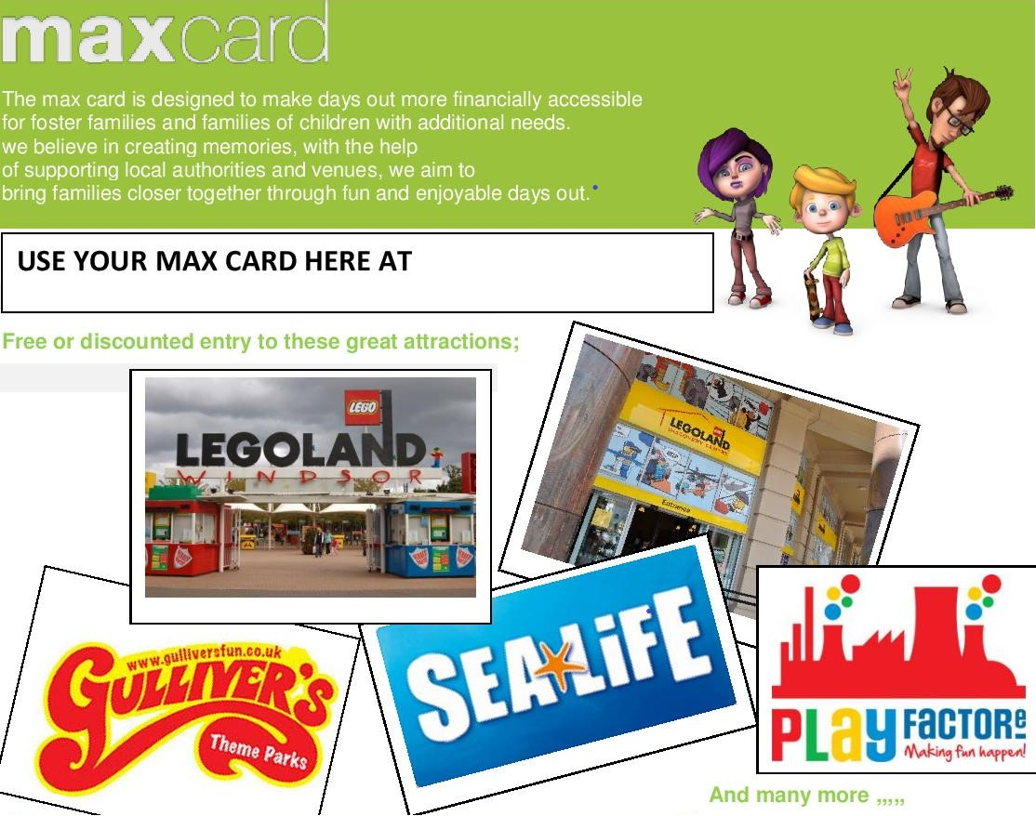
Liverpool City Council has partnered with Liverpool’s Parent Carers Forum LivPaC to deliver the maxcard discount initiative. Your details will be registered on both the Passport and with LivPaC.
To qualify for the maxcard the child / young person must reside within the Liverpool City boundary.
You will still be able to register on the Passport without registering with LivPaC but you won’t receive the maxcard.
To register then please go to Liverpool Local Offer SEND website and click of the Disabled Childrens Passport http://fsd.liverpool.gov.uk/kb5/liverpool/fsd/localoffer.page

Liverpool Parent and Carers Forum (LivPaC)
www.livpac.co.uk livpac@hotmail.co.uk

