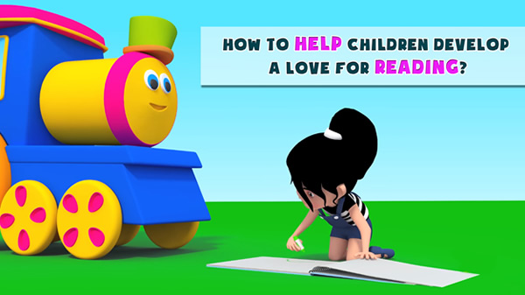

Dear Parents/Carers

On Tuesday 22nd October we will be hosting a reading coffee morning for EYFS and KS1 parents in the infant hall starting at 9am until approximately 10am. Places are limited so please return the slip below asap.

As a school, our focus is to promote a love for books and to engage all pupils through new and exciting ways of reading. During the morning we will explain how our new ‘Oxford Reading Buddy’ scheme works; share statutory reading expectations; model how to read a story in an engaging way alongside other ideas that will help our pupils to develop a passion for reading.

Many thanks for your continued support.

Yours sincerely

Mrs Holly Dwan & Miss Faye Richmond

__________________________________________________________________________________________

Reading Workshop

I will/will not be attending the reading coffee morning on 22nd October.

Child’s name_________________________ Class___________________

Number of adults attending ________

