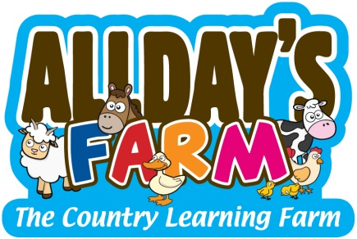

Visit from Allday’s Farm – The Country Learning Farm

Dear parents and carers,
We are delighted to inform you that Allday’s Farm – The Country Learning Farm will be visiting Dovedale Primary School on Tuesday 31st October to work with Year 1. This farm has been set up to travel to schools and events to teach people (young and old) about the wonderful animals that live in our countryside. We are fully insured and aim to give your children wonderful learning experiences that will link with their learning in the classroom.

On the day, we will be bringing; miniature horse, Kunekune Pigs, ferrets, pygmy goats, sheep, chickens, ducklings, rabbits, guinea pigs and tortoises. If your child has any allergies to any of the animals that we will be accompanied by, please let the school know and they will inform us.

Your child(ren) will be meeting and interacting with the farm and its animals over the course of the day. The children will be learning a variety of different things to develop their understanding, for example; how to compare and contrast different animals; understand what herbivores, omnivores and carnivores are; develop knowledge of animal names and the names of their young as well as learning what animals eat and how to care for them.

If you require any further information about Allday’s Farm you can find our website at www.alldaysfarm.co.uk or you can find us on Facebook at Allday’s Farm – The Country Learning Farm.

We are looking forward to seeing your child(ren) on Tuesday – we hope they enjoy Allday’s Farm - The Country Learning Farm.

Yours Faithfully,

Steven Allday - Allday’s Farm and Mrs Newby – Year 1 Leader

