Black History Week: Nina Simone
16th – 20th October 2017
This year, all Dovedale pupils from Year 3 to Year 6 will be researching the story of Nina Simone and her participation in the Civil Rights Movement.
Nina Simone was born Eunice Kathleen Waymon and was a pianist, singer, songwriter and civil rights activist. Her ambition was to become the first black concert pianist but the realities of racism and poverty forced her to direct her energies into blues and jazz. Her music was pivotal in the US civil rights movement. Amongst many other civil rights songs, she wrote and performed Mississippi Goddam in response to the bombing of a church in Alabama that killed four black children, Old Jim Crow, in reaction to segregation in the South, and Four Women, about four stereotypes of African-American women.

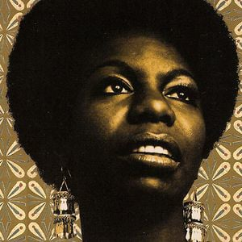

Pupils will be taking part in a range of exciting and inspiring activities, including:
- Producing art work inspired by Nina Simone’s songs.
- Writing their own protest songs.
- Using musical instruments to create music.
- Exploring Nina Simone’s friendship with Martin Luther King through writing and discussion.
- Taking part in critiques and evaluations of Nina Simone’s most famous protest songs and songs of hope and freedom.

