**Merseyside CDOP 7 Minute Briefing**

**The safest place for baby to sleep is in their cot**

**Safer Sleep for Baby**

**What to do**

No one wants to think about this

happening to a family they work with,

but there are things you can advise and talk to parents/carers about to help reduce the risks associated with Sudden Infant Death Syndrome (SIDS):

* Remind parents of the risks associated with unsafe sleeping practices
* If parents bed-share, discuss with them how they can minimise the risks

**Overheating**

**can increase**

**the risk of**

**baby dying**

If baby is sweating or

their tummy feels hot, there

are three things to check:

1. Room temperature – should be between 16-20oC. If it’s too hot turn down the heating or keep the window open during the day.

2. Baby’s clothes – Never let baby sleep wearing a hat and take off a layer of clothes if they are too warm (even if this means waking them).

Don’t worry if baby’s hands or feet feel cool, this is normal.

3. Baby’s bedding – Use sheets, lightweight blankets or a baby sleep bag. Take off a layer if baby is too warm.

**The six steps for safer sleep are**:

**1**. Keep baby away from smoke, before and after birth.

**2**. Put baby in a cot, crib or moses basket to sleep

– never fall asleep with baby on a sofa or chair.

**3**. Never fall asleep with baby after drinking

alcohol or taking drugs/medication.

**4**. Put baby to sleep on their back with their feet

to the foot of the cot.

**5**. Keep baby’s head and face uncovered and

make sure they don’t get too hot

**6**. Breastfeed your baby –

support is available if you need it.

Talking about safer sleep will help parents and carers to make an informed choice. It is important that parents are given accurate and clear information. Make sure you know the six steps, and why they matter.

During your conversations with parents, help them think about what grandparents, babysitters

and others who might care for the baby, will need

to know. Remind parents that those people

should also not drink alcohol or use

drugs/medication whilst caring for the baby.

**Questions to Consider**

How can we in this team use this information to safeguard infants?

Discuss where do we see parents with their infants?

Do we routinely ask about sleeping arrangements and other carers?

Do we routinely ask about alcohol, drugs and medication use?

Do we routinely give and discuss information about safer sleep?

Do we check where the baby is

sleeping and the temperature

control of this area?

**Why it Matters**

Some unexpected baby deaths can be

prevented by how babies are sleeping. The

campaign is aimed at preventing deaths where possible, and ensuring everyone who cares for a baby knows how to care for them more safely.

**Information**

“In 2014-15 Merseyside Child Death Overview Panel (CDOP) reviewed 11 deaths that fell into the ‘Sudden Unexpected/Unexplained Death’ category which were associated with co-sleeping/unsafe sleeping practices. This remains a key focus for the Merseyside CDOP”

**Background**

The work to promote safer sleeping for babies has been happening since 2009. This awareness highlighted that babies were dying and those deaths might have been preventable, if parents had known about safer sleeping. The current campaign ‘Safer Sleep for Baby’ gives six easy steps.

**5**

**2**

**4**

**3**

**1**

**7**

**6**

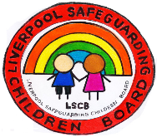

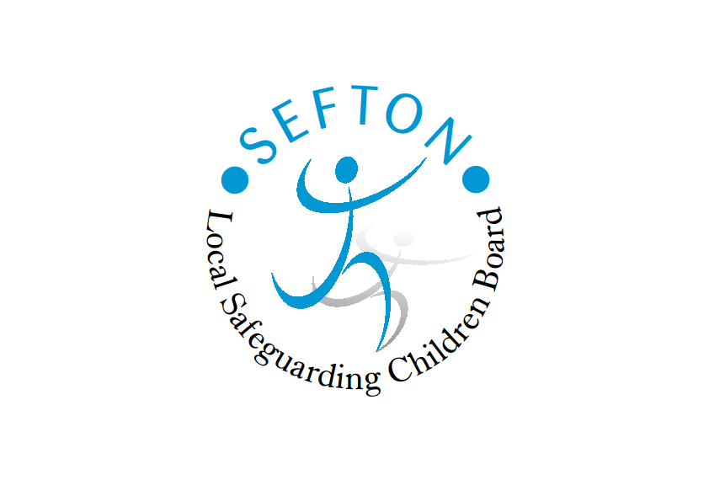



**http://www.safeguardingchildrenea.co.uk/files/sgc/st%20helens%20logo_small.jpg**

**What are 7 Minute Briefings?**

1. **Background**

Seven minute briefings are based on a technique borrowed from the FBI. It is based on research, which suggests that seven minutes is an ideal time span to concentrate and learn.

Learning for seven minutes is manageable in most services, and learning is more memorable as it is simple and not clouded by other issues and pressures.

1. **Why it matters**

The LSCB is aware of increasing pressure on services, which make it difficult to release staff to attend training, as well as the need to keep learning and developing to maintain a skilled workforce, and that these short, team based learning events might be a helpful way to support.

1. **Information**

The context of the briefings will be a mixture of new information (such as learning from Serious Case Reviews) or a reminder/repeat of basic information with challenge to think about the application to practice in the team.

Their brief duration should also mean that they hold people’s attention, as well as giving managers something to share with their staff.

It is planned to send out one briefing per month, to any manager who wants to use it. The structure of every briefing will be the same, so it becomes easier to find the information once the managers are familiar with the format. Clearly the briefings will not have all the answers, but it is hoped that they will act as a catalyst to help teams and their managers reflect on their practice and systems.



The briefings will be an invitation to think and will end with discussions points, which teams can use if there is time, but can also be omitted. The briefing will stand alone, even without discussion, although if time is allowed for the discussion this is likely to enhance the learning of the team.

1. **Delivery**

Briefings should be delivered face to face, so as to ensure they are not misunderstood, and there can be discussion of the subject to ensure they do not become lost in paperwork or e-mails.

If you or your team have suggestions for future briefings you would find helpful, please send your suggestions to the LSCB Learning & Development Officer:

Sarah Herron [sarah.herron@knowsley.gov.uk](mailto:sarah.herron@knowsley.gov.uk)

Nicky Walsh [Nicky.Walsh@liverpool.gov.uk](mailto:Nicky.Walsh@liverpool.gov.uk)

Beverley Hall [Beverley.hall@sefton.gov.uk](mailto:Beverley.hall@sefton.gov.uk)

Niccie Jones [NiccieJones@sthelens.gov.uk](mailto:NiccieJones@sthelens.gov.uk)

Bryony Baker [bryonybaker@wirral.gov.uk](mailto:bryonybaker@wirral.gov.uk)

1. **What to do**

The expectation is that team leaders will present briefings to their staff once a month. It will be important to make the topic relevant to your service. The briefings should not be mixed in with ordinary day to day issues as this will diminish their impact.

**Questions to consider**

**How do you organise these briefings in your service?**

**How do you ensure they are given both time and gravitas?**